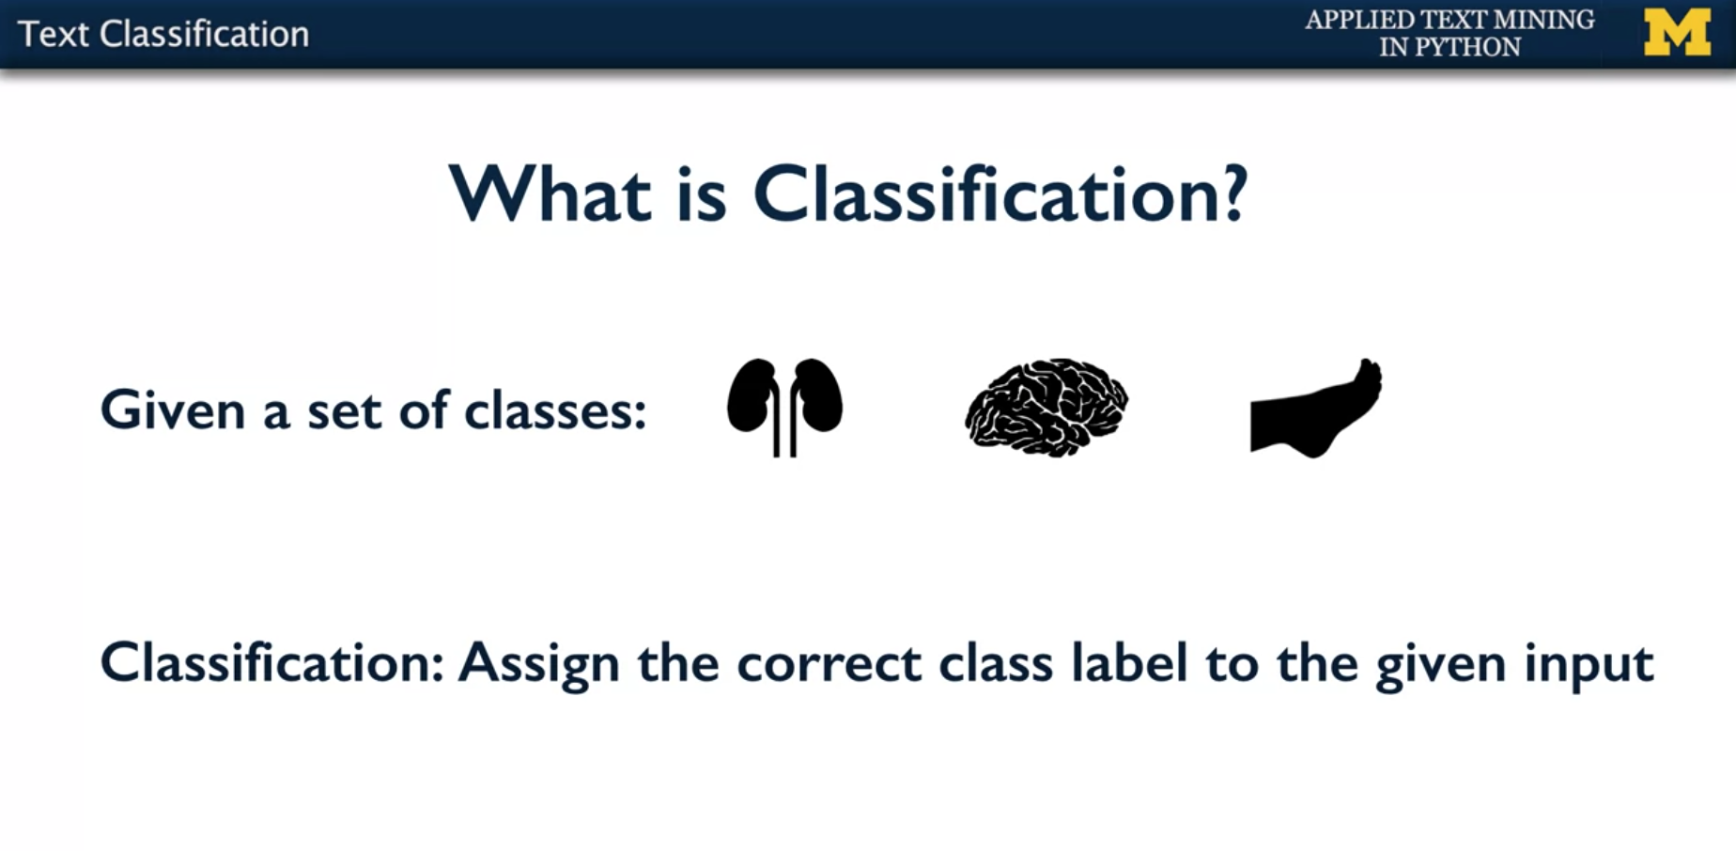

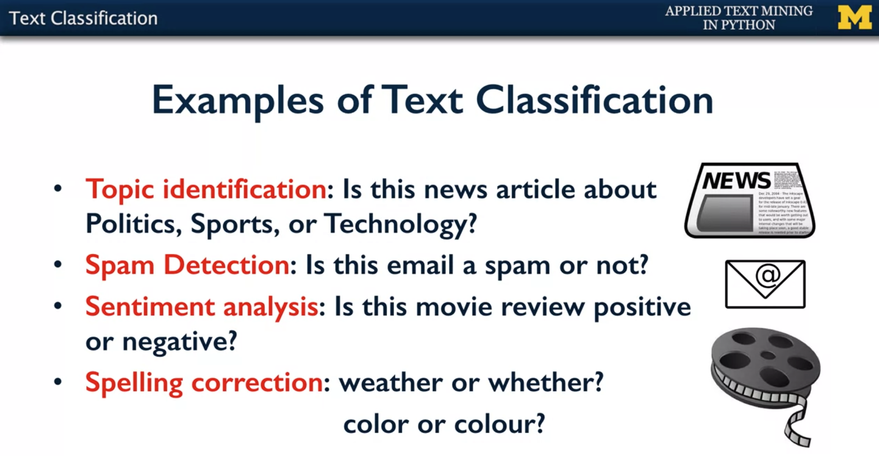

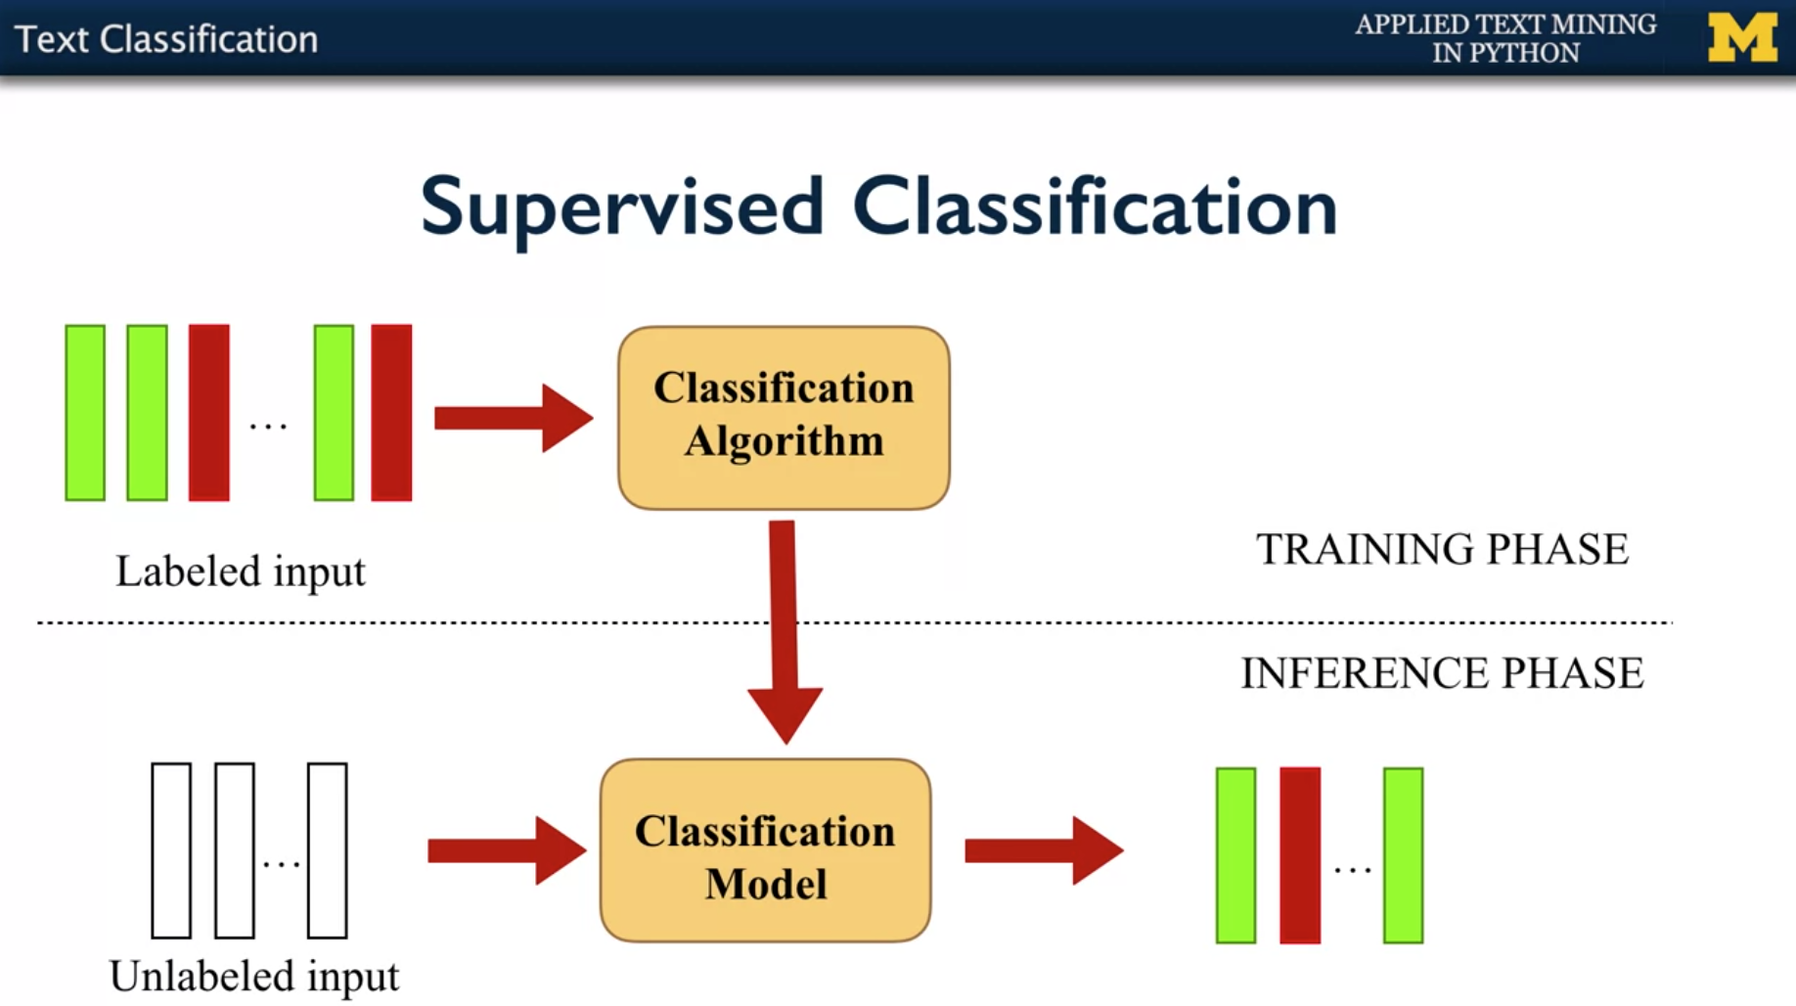

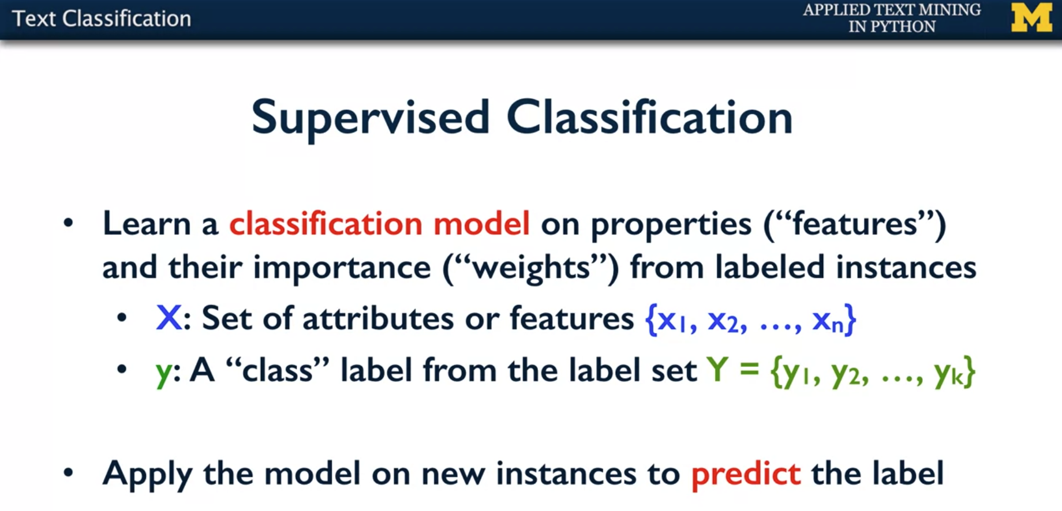

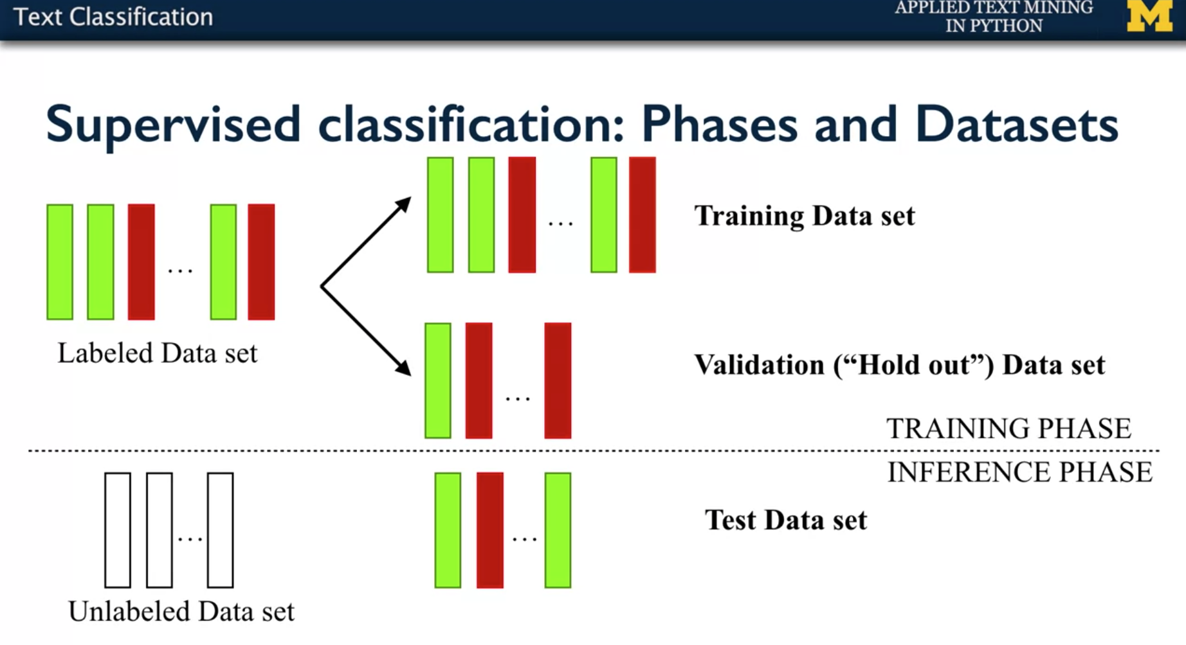

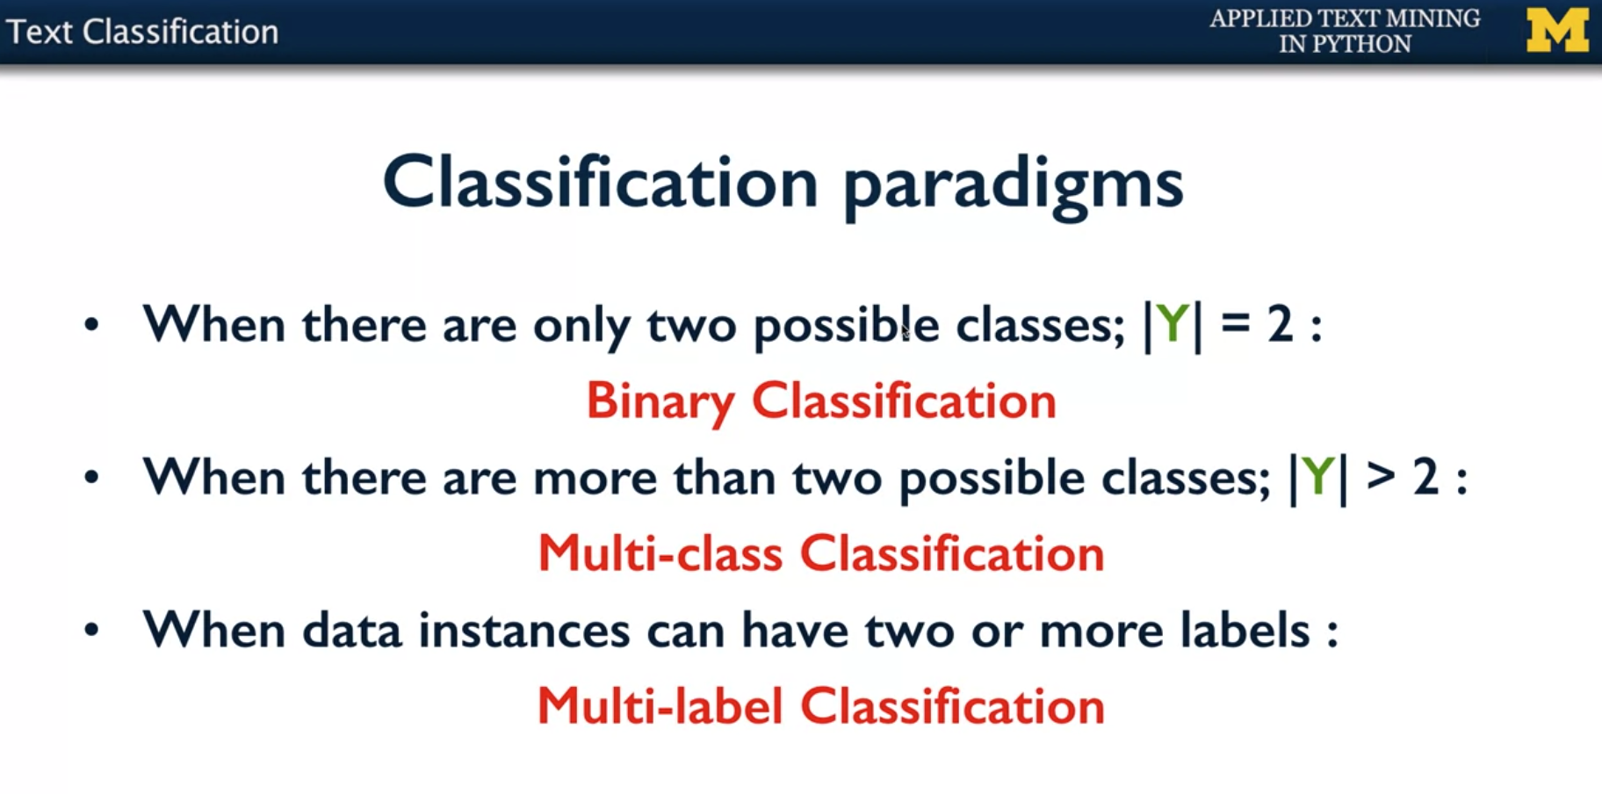

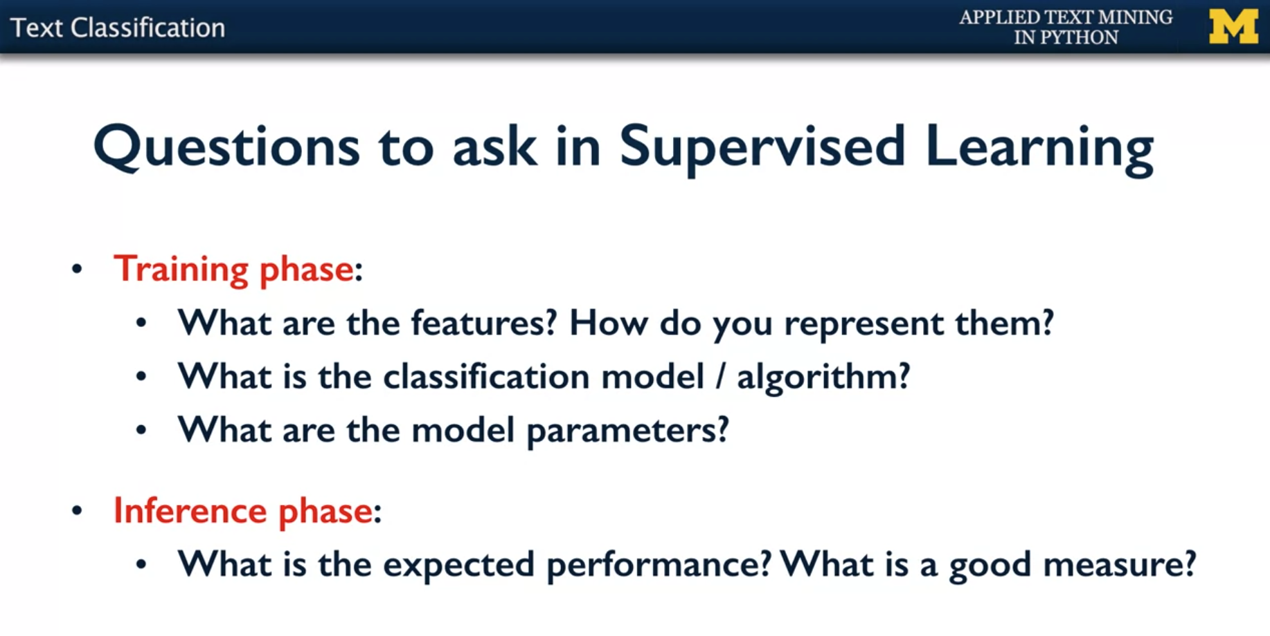

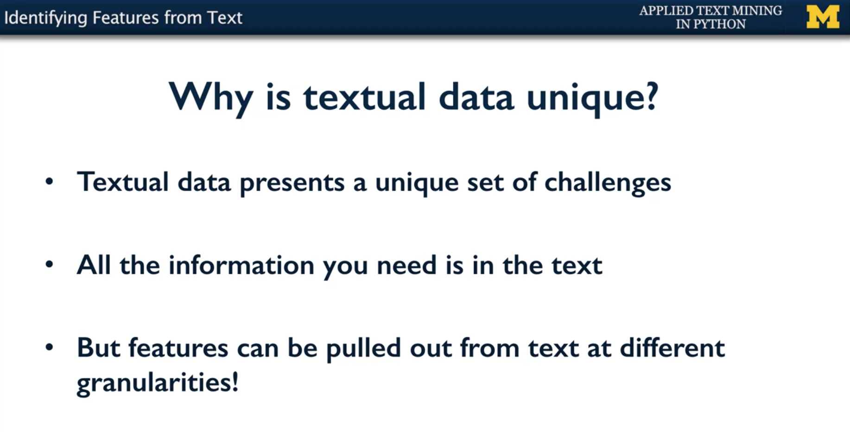

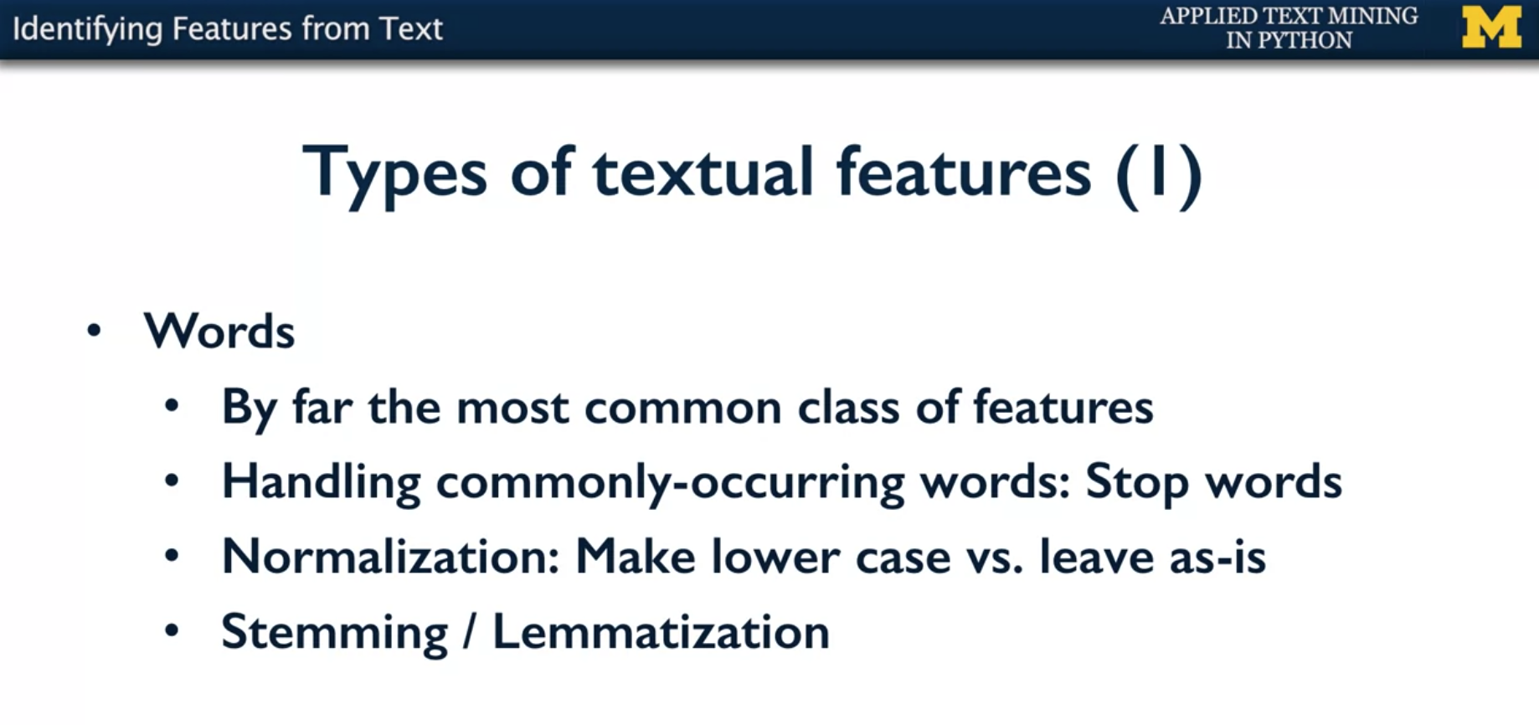

* But more generally the word the is not as important for a classification task than any other word. Let's say if you're talking about politics and you have parliament as a word.
* Parliament as a word is more important than the word ‘the’ to determine whether the document belongs to the politics class.
* There are also issues about stemming and lemmatization. So for example, you don't want plurals to be different features. So you would want to lemmatize them or to stand them.

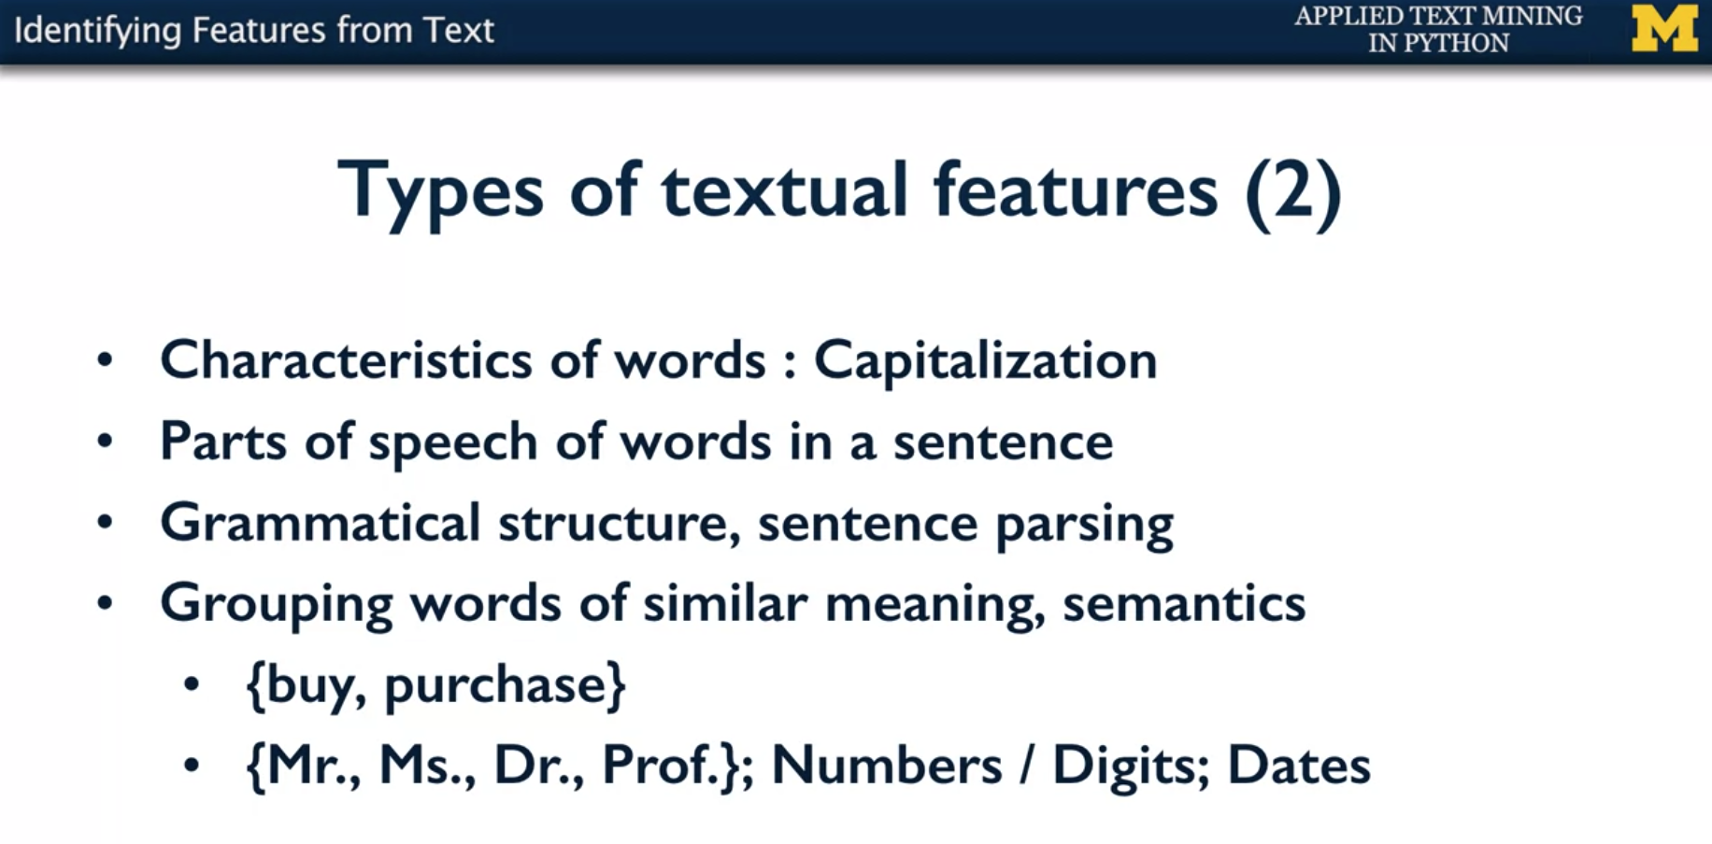

* White House, with the W capitalized and the H capitalized, it's very different from a white house, a white house, right?
* You could use parts of speech of words in a sentence. And those could be a feature. So for example if it's important to say that this particular word had a determinant in front. An example would be the weather, whether example.
* You also might want to know the grammatical structure or parse the sentence and get the sentence parse structure to see what is the verb associated with a particular noun. How far is it from the associated noun and so on.
* And then, you may want to group words of similar meaning to have one feature to represent a set of words. An example would be buy, purchase, and so on.
* But it could also be other groups, like titles or honorifics, like Mr, Ms, Dr, Professor, and so on. Or the set of numbers, or digits, because you don't want to specifically have a feature for zero and other features for one, and so on, all the numbers. So you might want to say, if it's a number anywhere between 0 to 10,000, I'm just going to call it something, a number, right, so suddenly you've reduced 10,000 features into one.

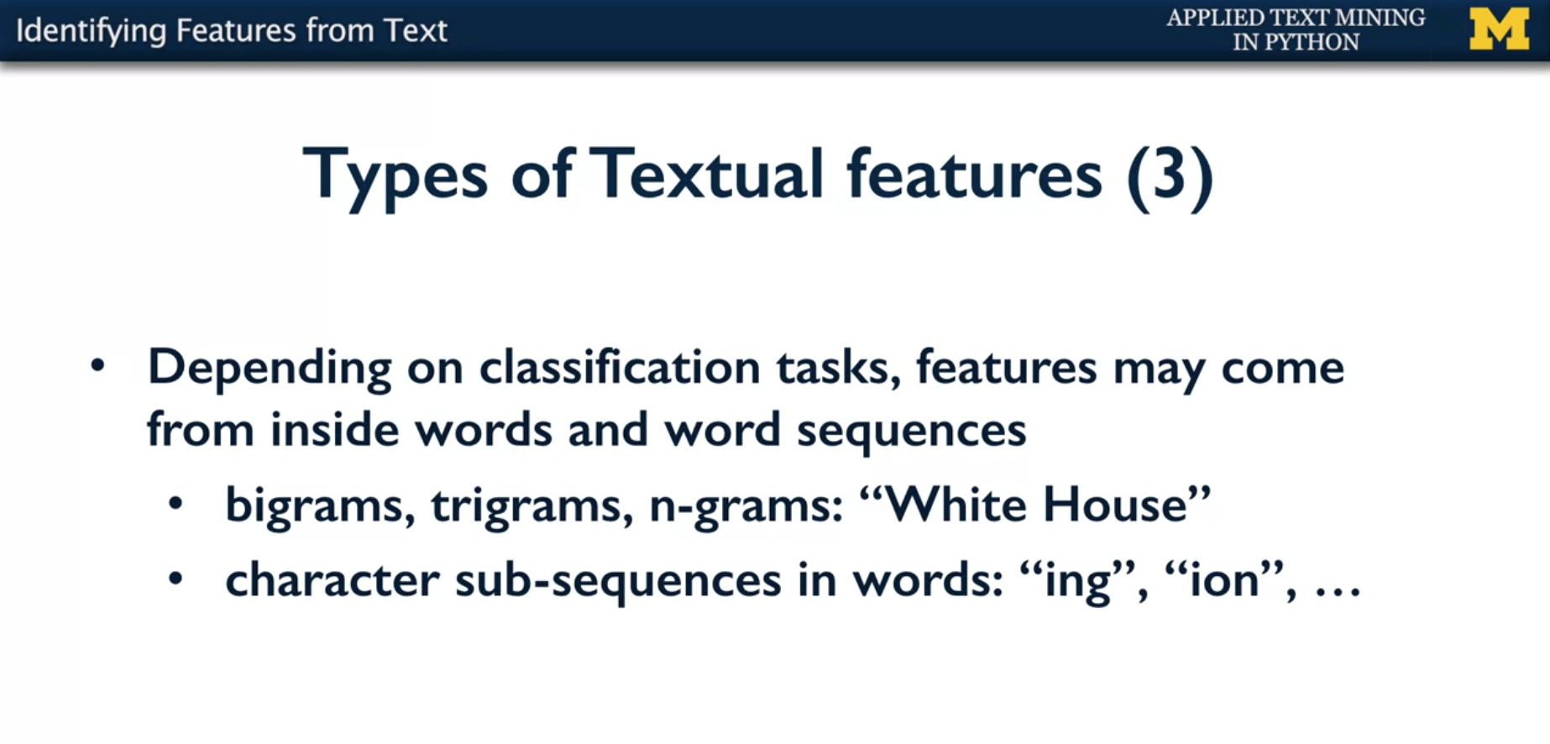

* You may have features that come from inside the words or have features with word sequences. An example would be bigrams or trigrams. The White House example comes to mind. Where you want to say, White House, as a two word construct as a bigram is conceptually one thing. As compared to white and house as two different features, two different things.
* You may also want to have character sub-sequences such as ing or ion. And just by looking at it you know that ing is basically saying it is a word in its continuous form, right? So, just looking at ‘ing’ in a word, we'd be able to call it a verb. And ion more likely at the end of a word would be a noun of some form. So just these character subsequences can help you identify some classes if that is important for this particular classification task that you have.

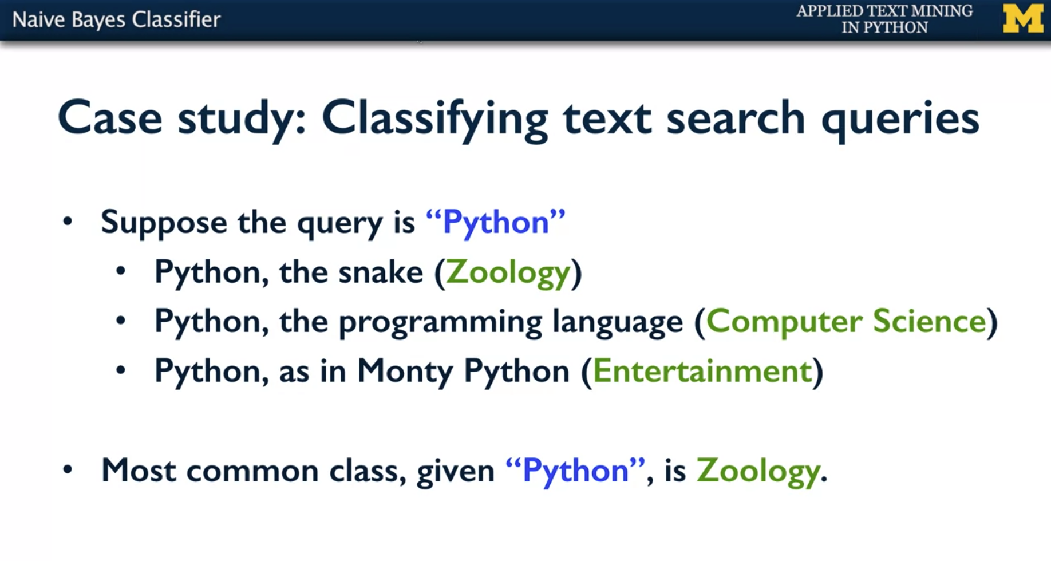

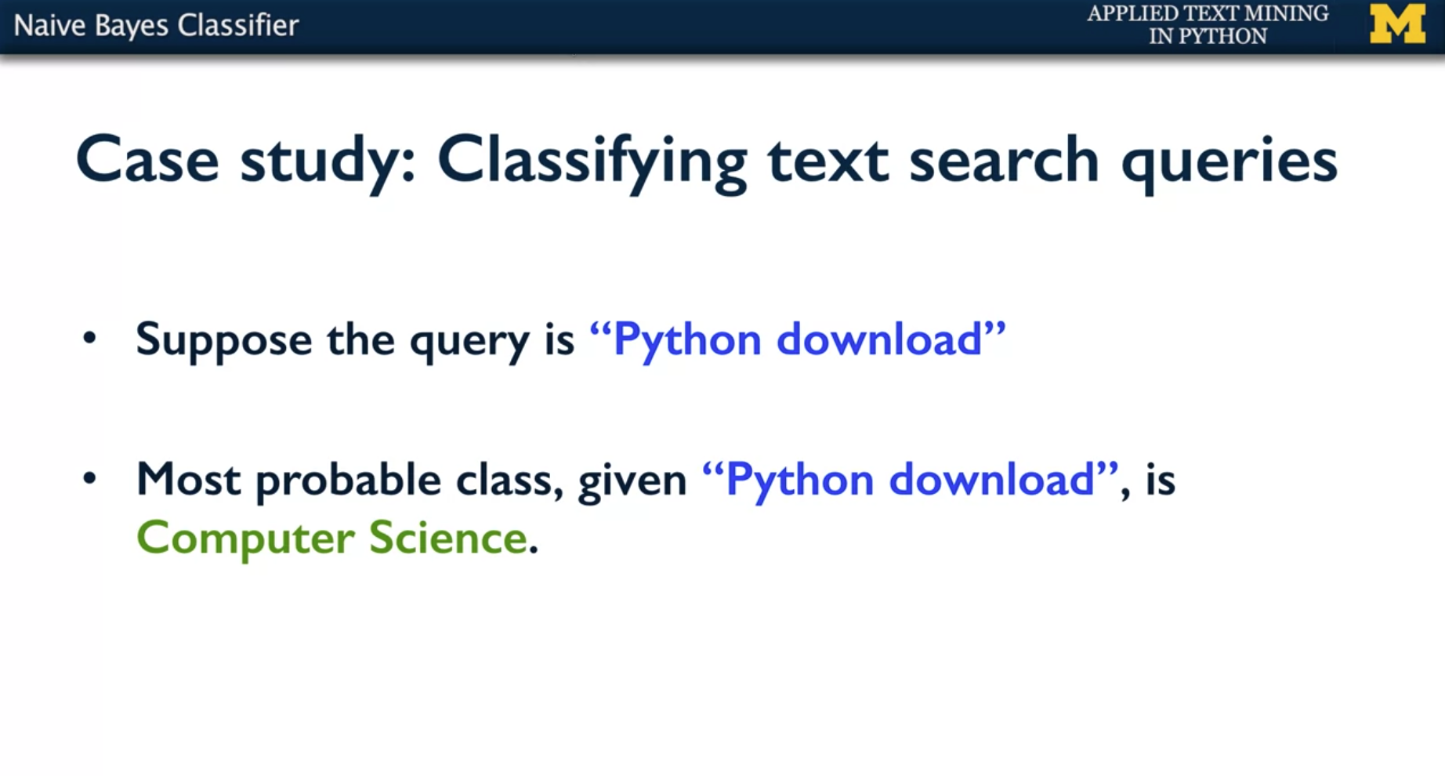

* Then you have another word and this time is "Python download". And then you can say that the most probable class is in fact computer science. So what just happened there?
* You had a model, in this case a probabilistic model that tells you the likelihood of a class before you have any information. And then when you are given new information, you update that likelihood of the class.
* So this change is what is in the crux of this Naïve Bayes classifier. You have something called prior probability that is the prior knowledge or the prior belief what the label belongs to. So you have a prior probability for each of them. And by basic probability you know that these are the only three options. But among the three, entertainment is more likely.
* And then when you have new information like the x is Python and input is Python, so when you have new information your probability and likelihood changes.
* Your probability of entertainment given the input is Python is suddenly lower. And the probability of y being computer science given x is Python is higher. And the probability of y given zoology is even higher. That's why you would say that "Given the input Python, the label is zoology".

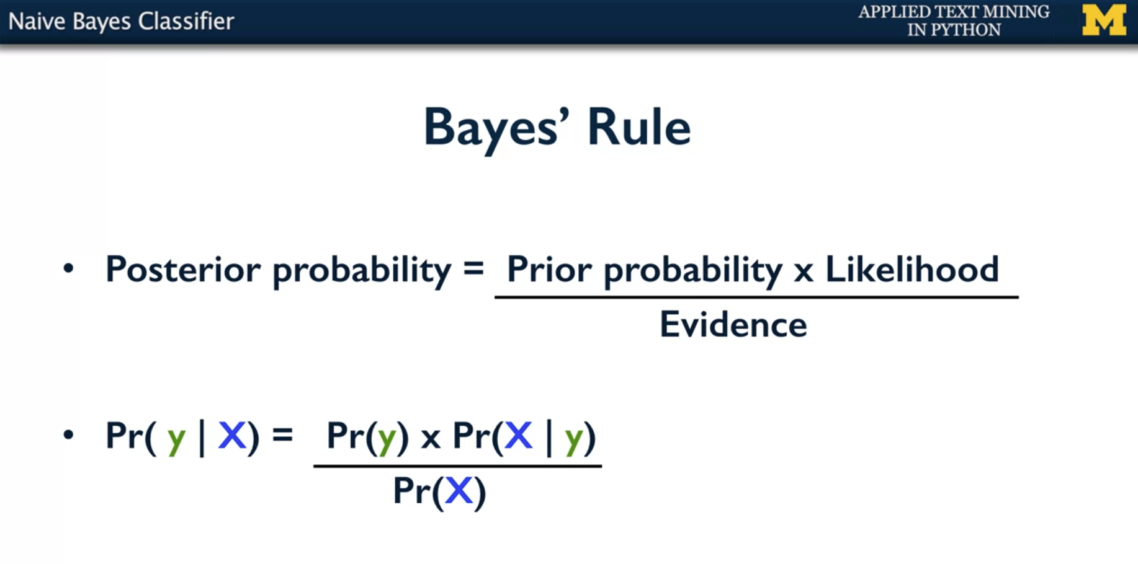

* So this is encapsulated in what is called Bayes Rule or Based theorem
* The posterior probability depends on your prior. But then also depends on the likelihood of that happening or that event happening. And divided by the evidence.
* So in mathematical terms it comes to the probability of y given X is probability of Y which is the prior probability. And probability of X given y which is the likelihood of having the data as X given y.
* That means, if you know that the label is zoology, the probability of seeing Python is so.
* Or if you know that the label is entertainment the, the probability of seeing Python in entertainment is so and so and that is lower. That's significantly lower than the other one. Then the class was zoology.

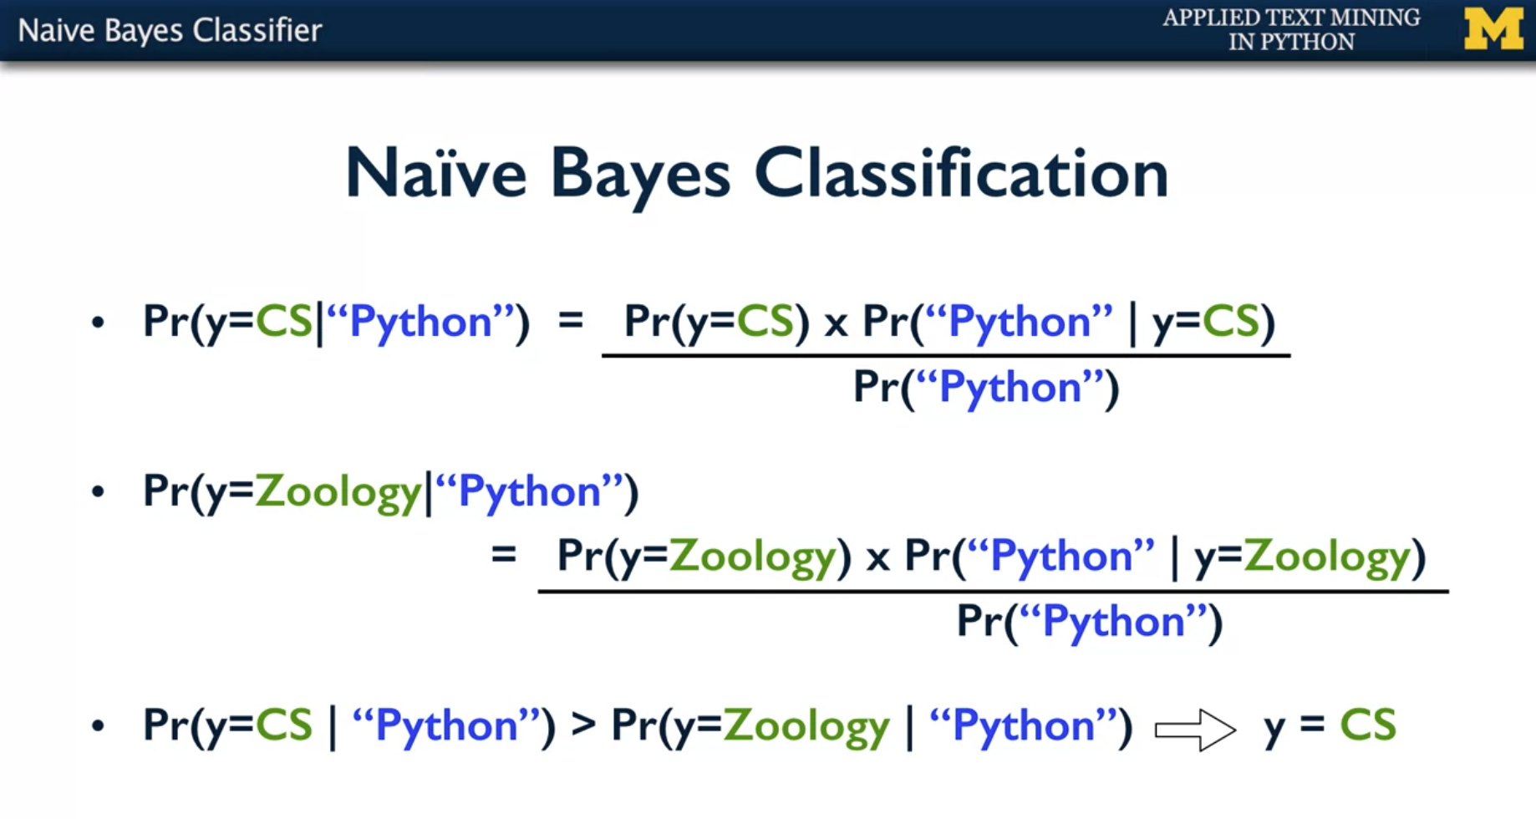

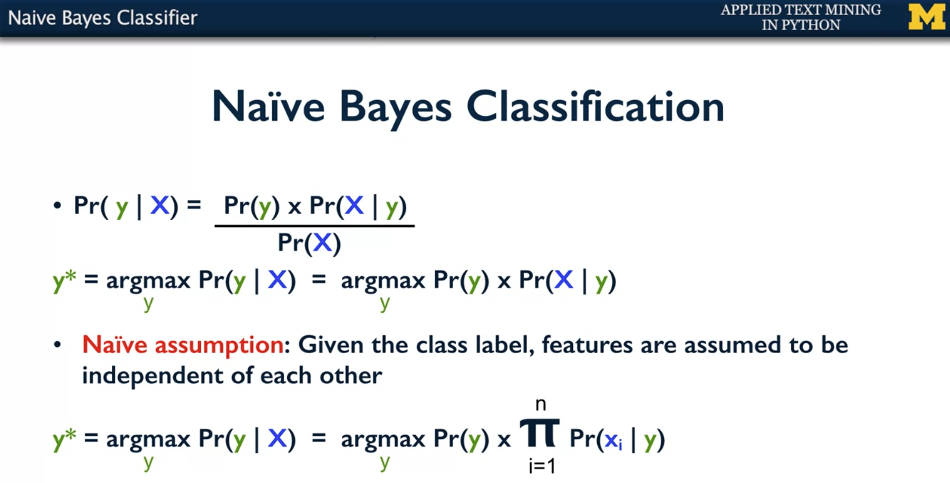

* The Naïve Bayes classification model just is interested in which of the three labels is more likely.
* So you know that y belongs to one of the three classes. Entertainment, computer science, or zoology. It's only important to know which among those three is higher.
* And so, the true label, or the predicted label I should say, y* is the y that maximizes probability of y given X.
* And then that computation does not matter what the probability of X itself is. And you can remove it then because it does not matter, it doesn't change with the label assigned to it.
* This in addition to what is called the Naïve assumption of Bayesian classification forms the Naïve Bayes classifier.
* And the Naïve assumption is that given the class label, the features themselves are independent of each other. That is given the label is y, probability of capital X given y is just individual feature probabilities.
* Probability of x_i given a product of all of those. That's the product that goes from the first feature to the end feature. This is the final formulation of a Naïve Bayes classifier.

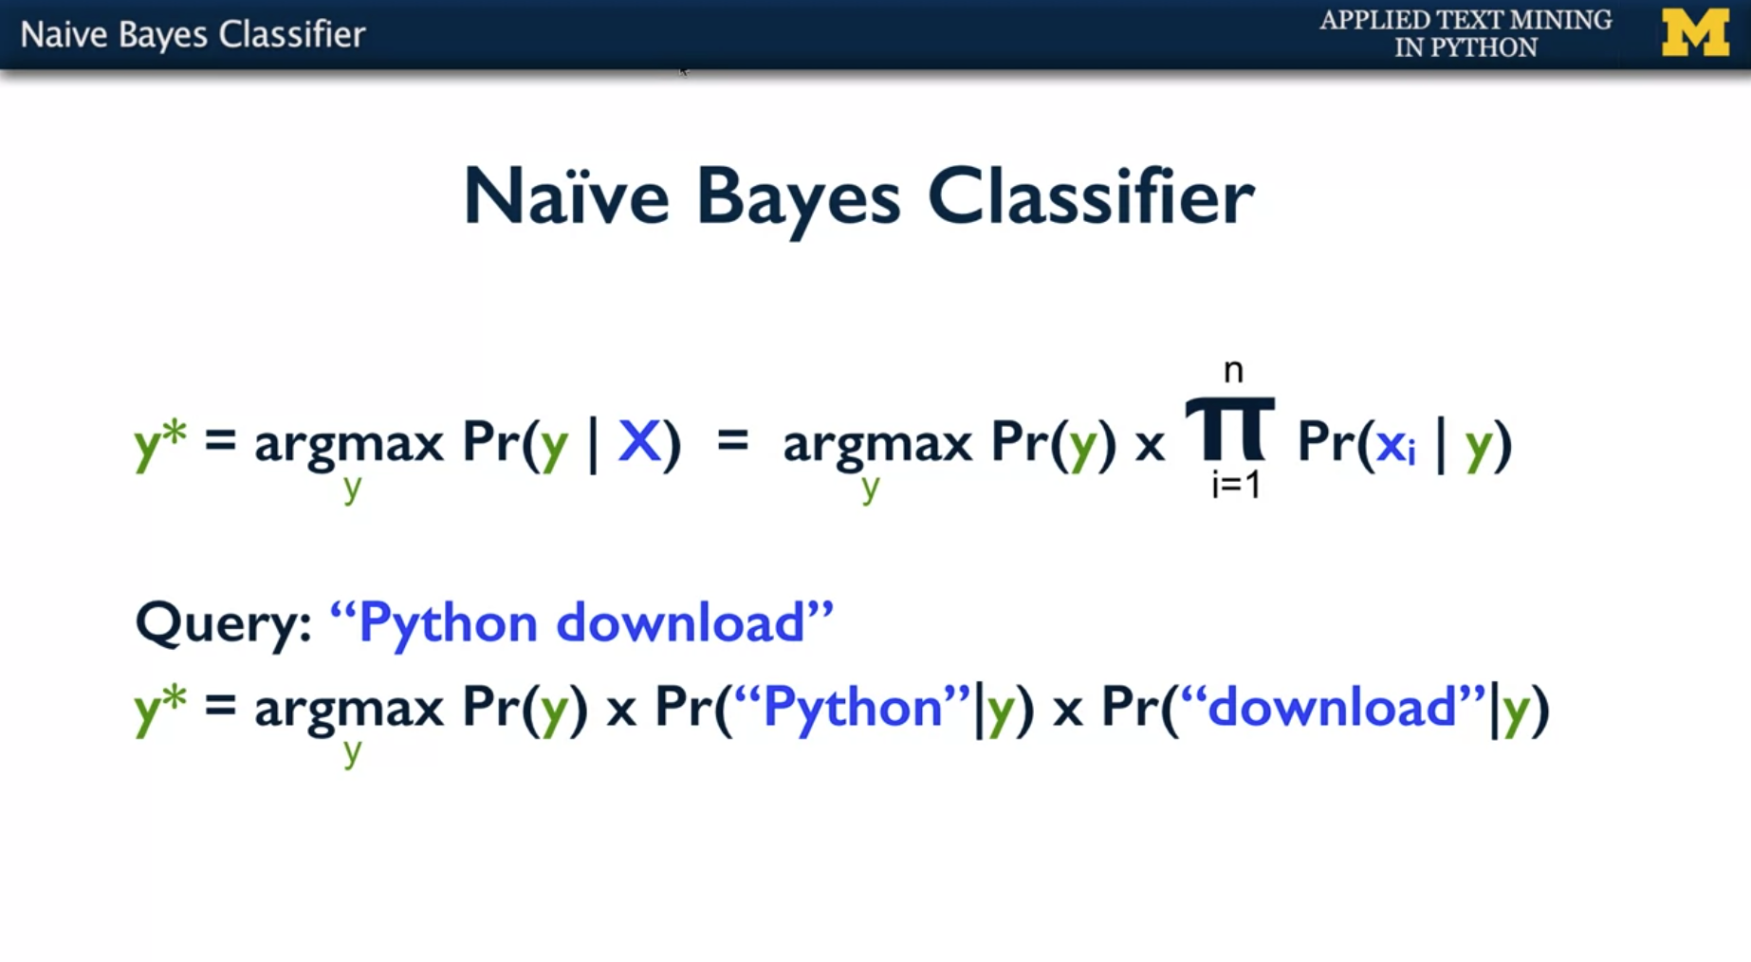

* So the formula stands like this. The predicted label y is the y that maximizes, the argument that maximizes this computation of probability of y given X.
* Which is computed using Bayes Rule as probability of y, that is the prior, times T independent products of individual features given y. So that's the likelihood of probability of capital X given y.
* So for example, if the query is Python download, you're going to say "The predicted y is the y that maximizes probability of y. Probability of Python given y, and probability of download given y.
* So for example, if it is zoology, you know that the probability of zoology is low. People don't typically ask zoology queries. But then the probability of Python given zoology is very high. However, the probability of download given Python is very low.
* However, in the case of computer science, probability of computer science queries in general is somewhere in the middle. Probability of Python given computer sciences not up there but also significant. Whereas probability of download given computer science is very significant.
* And a product of all of the three makes computer science to be the best predicted leap.

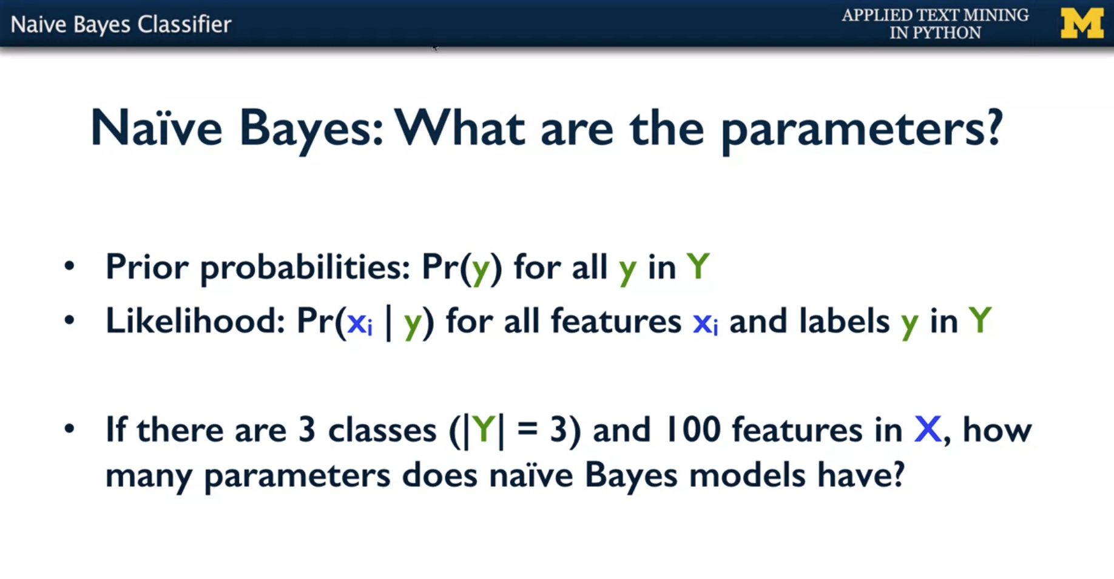

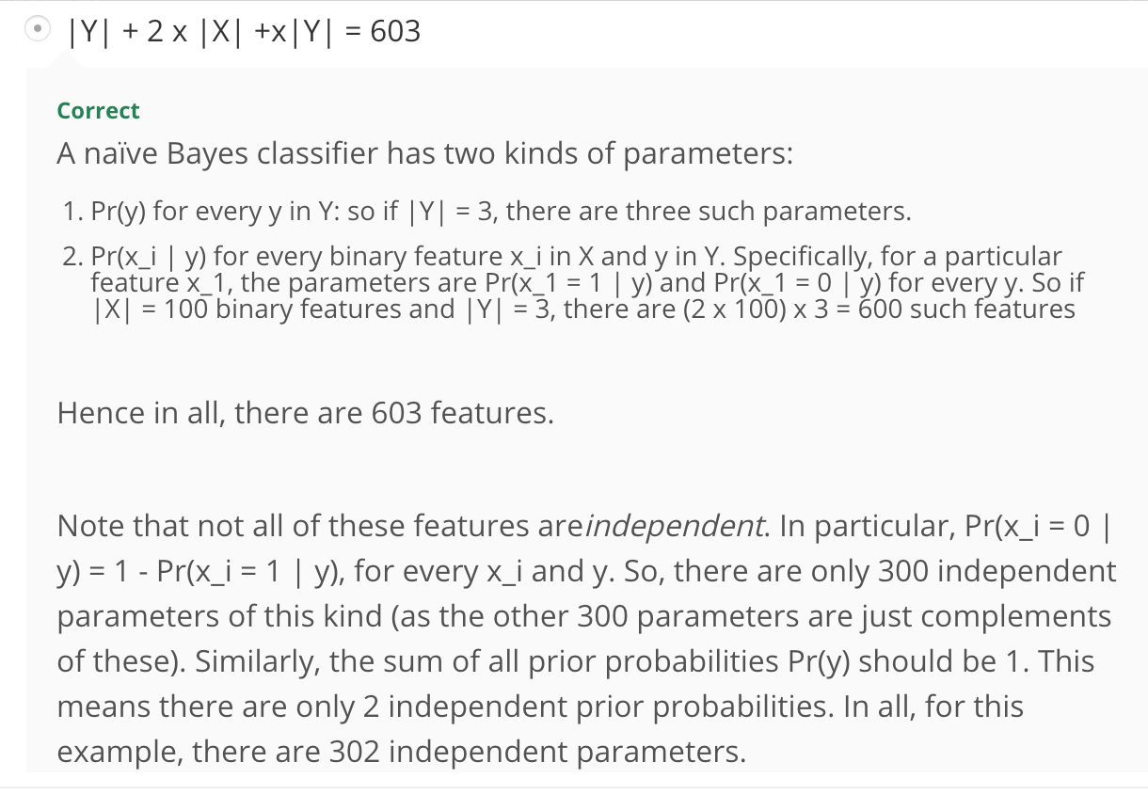

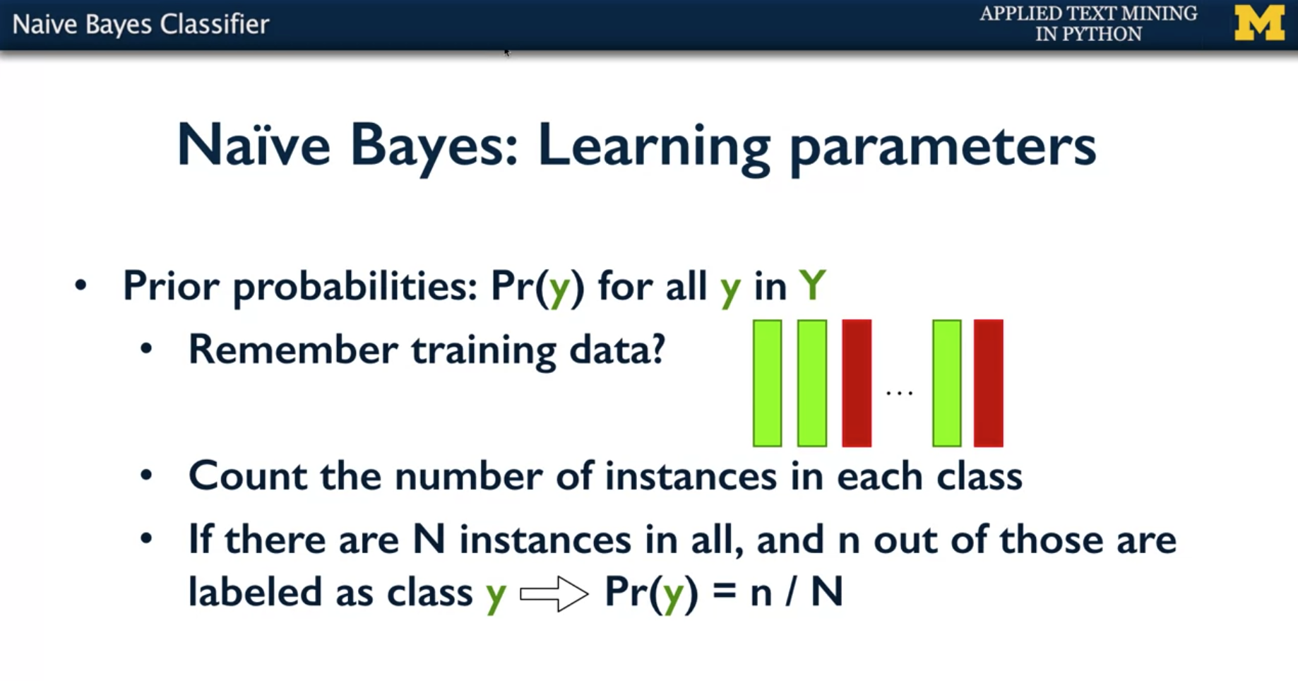

* So you have prior probabilities like probability of y for all Y in the set of labels. How do you identify that?
* Well, you have the training data. So you have the set of documents are all the queries that are labeled as which class they belong to. So you can just count the number of instances you have in your training data in each of these classes.
* In the example I gave, I gave you two examples of entertainment and one each of computer science and zoology. So your class distribution just with four instances would be half for entertainment, one quarter for zoology, and one quarter for computer science.
* In general, if there are any instances and small enough ones that belong to a particular class y then your probability of class y is small and or capital N.

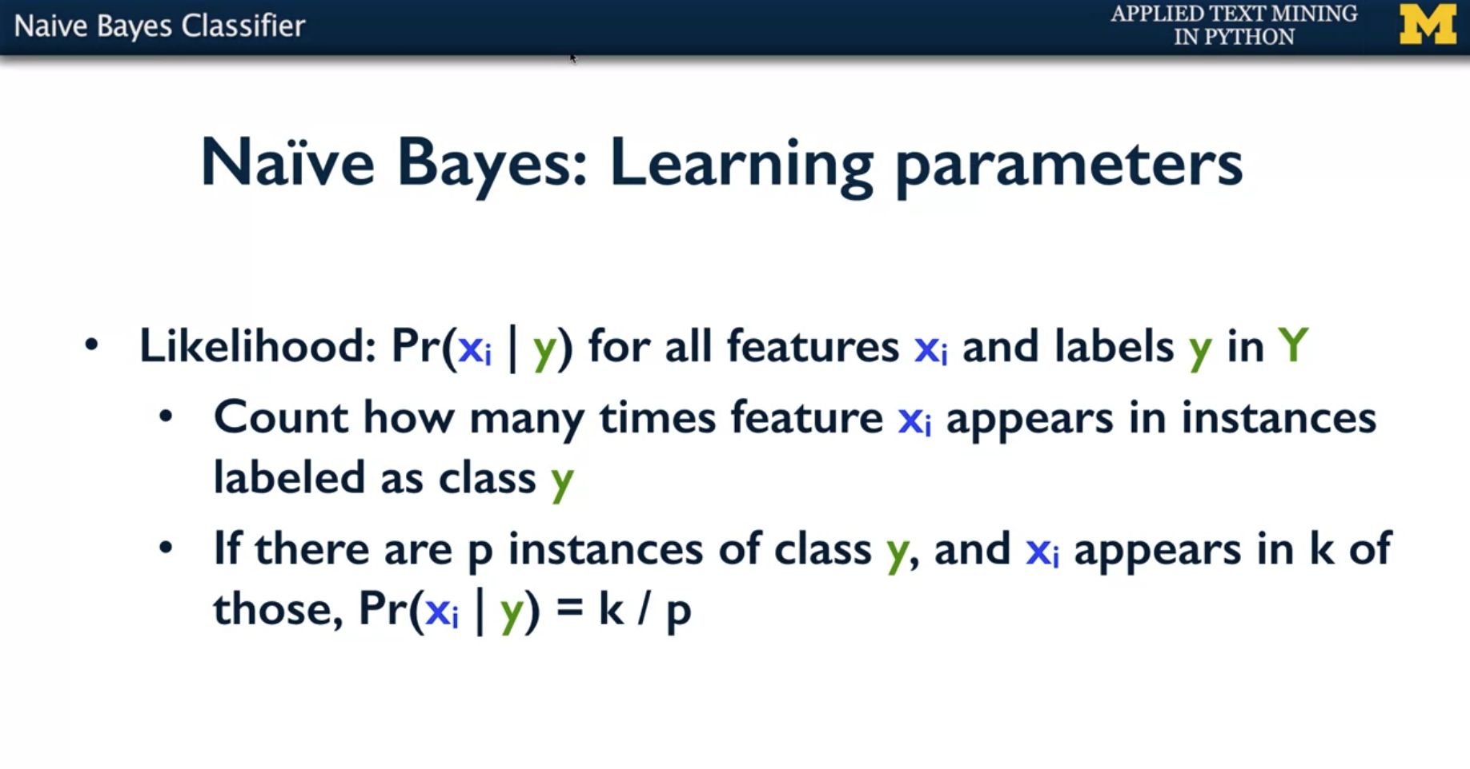

* The next set of parameters you have is likelihood. So recall that likelihood is probably of x_i given Y for all features x_i and for all labels y. So it's a combination of the many, many features here.
* How do you count those? So you only focus on the instances that were labeled class y and among those see how many times the feature x_i occurs.
* So for example, you will only look at documents that belong to the computer science class and among those you would count how many times Python appears.
* So there are p instances of class y and x_i the feature x_i appears in k of them then the probability of x_i and y would be k / p. When you do this counting there is a slight problem.

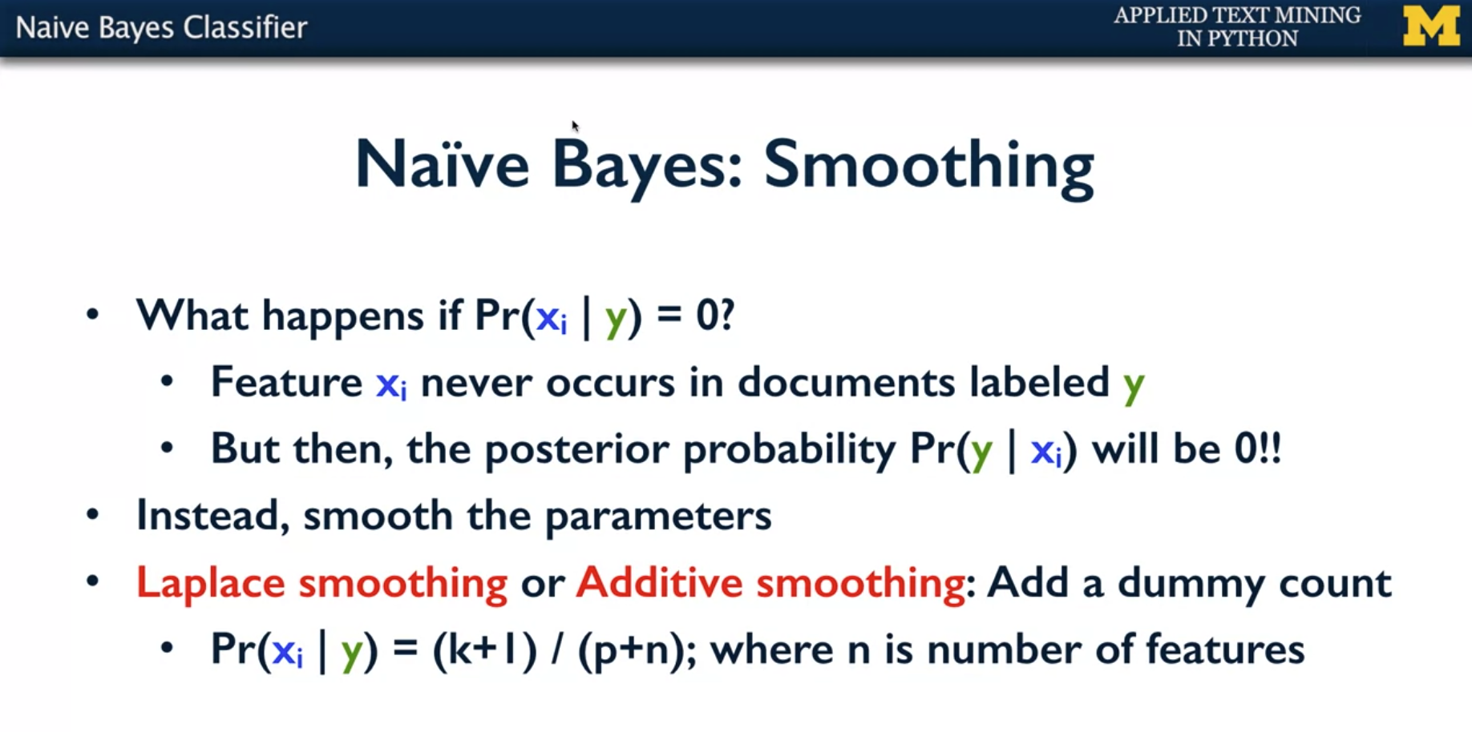

* If you have never seen the word "actor" in queries that were labeled entertainment. Then the probability the way you compute it would be zero.
* But that is a problem because if you have the probability to be zero and it is multiplied to all the other probabilities, the overall probability will end up being zero. You don't want to be that strict. So you don't want to say that the posterior probability of y given x_i will be zero
* So what you would want to do instead is to smooth the parameters and then you smooth the parameters. One of the options to do it would be just add a dummy count. You say, it's never the case that the count is zero. So I add count of one to every word in every class.

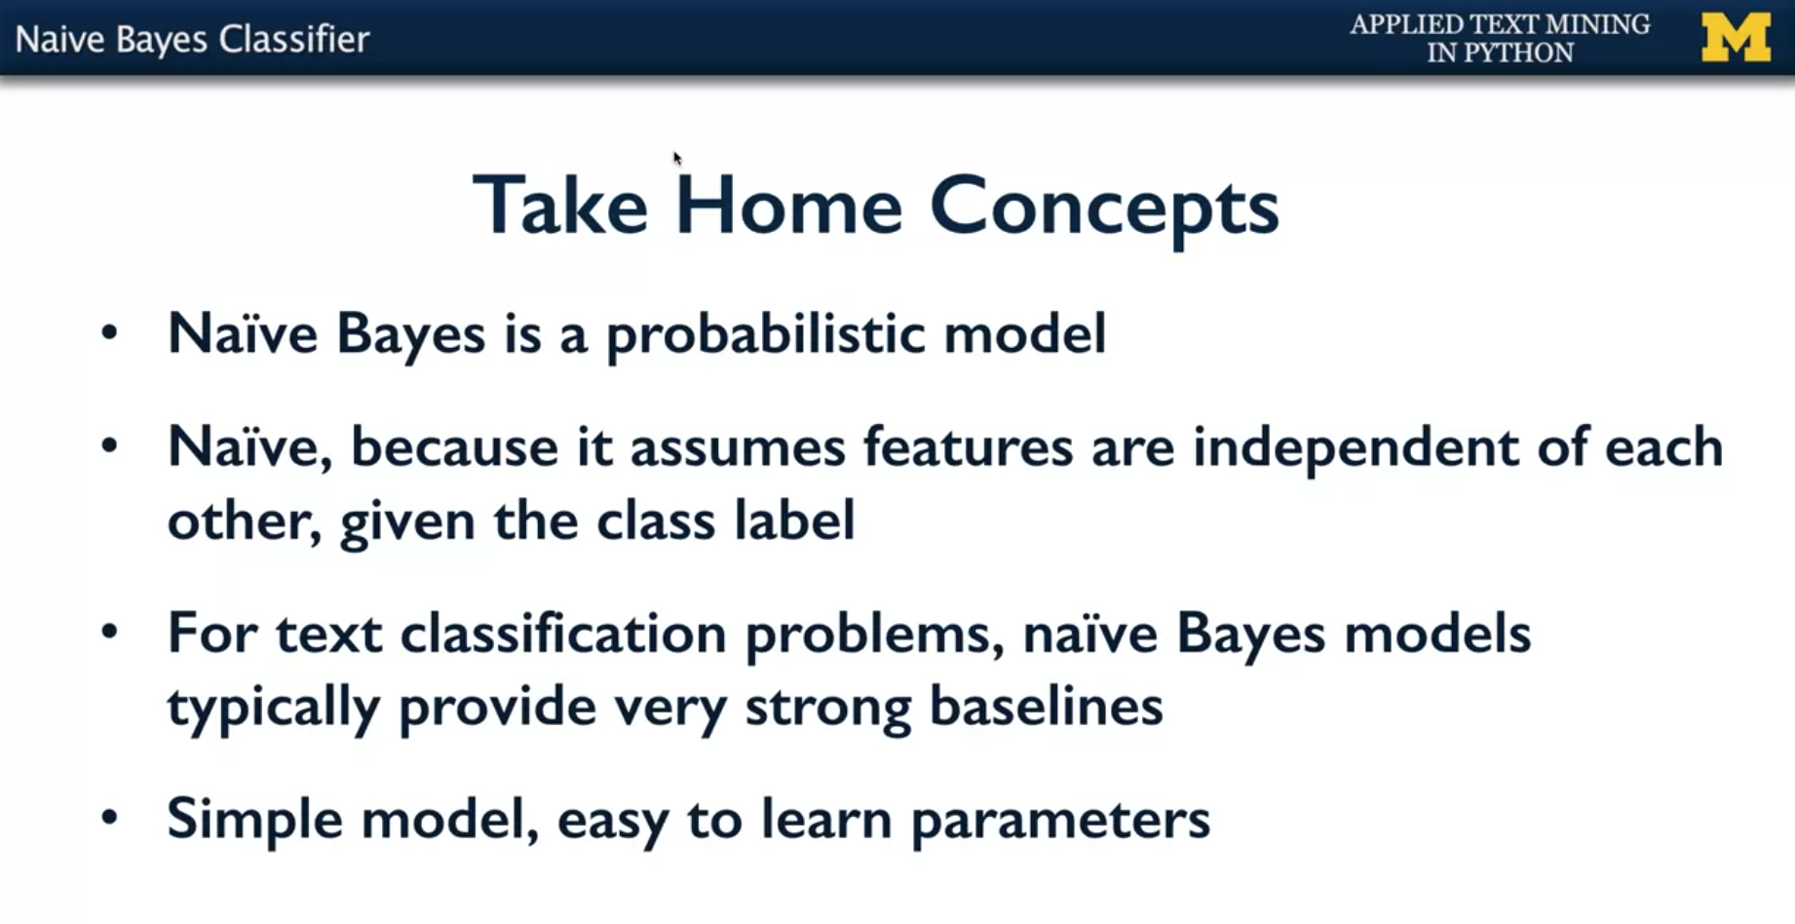

* The big take home messages from this video is that Naive Bayes is a probabilistic model and it is called Naive because it assumes that features are independent of each other given the class label.
* It is Naive because it's actually not necessarily true even for text.
* So for example, the fact that you have "White House" as two words but together having a significantly different meaning. If you see the word "White" with a capital W, the chance that it is followed by "House" is very high. So these two features of "White" and "House" are not really independent of each other.
* Even so, for text classification problems, Naïve Bayes models actually typically provide very strong baselines. It is traditionally the first one you should try because. It will give you the benchmark or a baseline that is pretty strong.
* So the big message is Naïve Bayes is a very important classifier for text classification and should be the first one you should try.

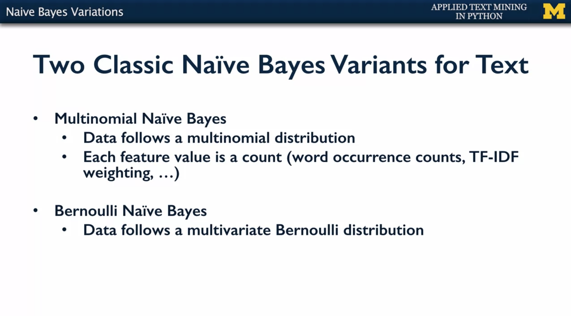

* There are two ways in which Naïve Bayes features could be learned. You have the multinomial Naïve Bayes model and the other one would be a Bernoulli model.
* The multinomial Naïve Bayes model is one in which you assume that the data follows a multinomial distribution.
* So what does that mean? It means that when you have the set of features that define a particular data instance, we're assuming that these each come independent of each other and can also have multiple occurrences or multiple instances of each feature.
* So, counts become important in this multinomial distribution model. So you have each feature value, a some sort of a count or a weighted count.
* Examples would be word occurrence counts or TF-IDF weighting and so on.
* so for example, if the statement is to be or not to be, and you want to somehow say that the word to occur twice, the word be occur twice, the word or occur just once and so on, you want to somehow keep track of what was the frequency of each of these words.
* And then, if you want to give more importance to more rare words, then you would add on something called a term frequency, inverse document frequency weighting. So you don't, not only give importance to the frequency, but say how common is this word in the entire collection, and that's what the idea of weighting comes from.
* So for example, the word THE is very common, it occurs on almost every sentence, it occurs in every document, so it is not very informative. But if it is the word, like, SIGNIFICANT, it is significant because it's not gonna be occurring in every document. So, you want to give a higher importance to a document that has this word significant as compared to the word the, and that kind of variation in weighting is possible when you're doing a multinomial Naïve Bayes model.
* The second model is the Bernoulli Naïve Bayes model.
* Here, the assumption is that the data follows a multivariate Bernoulli distribution, where each feature is a binary feature, that is, the word is present or not present, and it's only that information about just the word being present that is significant and modeled and it does not matter how many times that word was present.
* In fact, it also does not matter whether the word is significant or not in the sense that is the word THE, which is fairly common in everything, or is the word something like SIGNIFICANT, which is less common in all documents.
* So when you have just the binary features, I mean, just a binary model for every feature, then the entire data, the set of features follows what is called a multivariate Bernoulli model.
* So these are the two standard classic variants in Naïve Bayes, and you'll see that most of the approaches and most of the tools that you have for Naïve Bayes modeling give you that option, give you the option of multinomial Naïve Bayes or Bernoulli Naïve Bayes. It's fairly common in text documents to use the multinomial Naïve Bayes, but there are instances where you would want to go the Bernoulli route, especially if you want to somehow say that the frequency is immaterial and it's just whether the presence or absence of a word that is more important.